BUG REPORT FOR REGISTRATION FORM

|  |  |
| --- | --- |
| Project name | Job registration form |
| Client name | Levitica |
| Reference document | FRS |
| Created by | Naveen |
| Creation date | 15/04/2024 |
| Approval date | TBD |

BUGS LIST:

1. Incorrect title name for application
2. Allignment is not clear for the fields
3. Fields are accepting invalid inputs
4. Register button is not working properly

Incorrect title name for application

1 Enter URL <file:///C:/Users/pc/AppData/Local/Temp/68977676-932d-4e3a-ad4b-5031b00280b3_zipfile.zip.0b3/testing/Form.html>

2 User will navigate to the registration form page.

3 Observe the title name for the tab is not apt title.

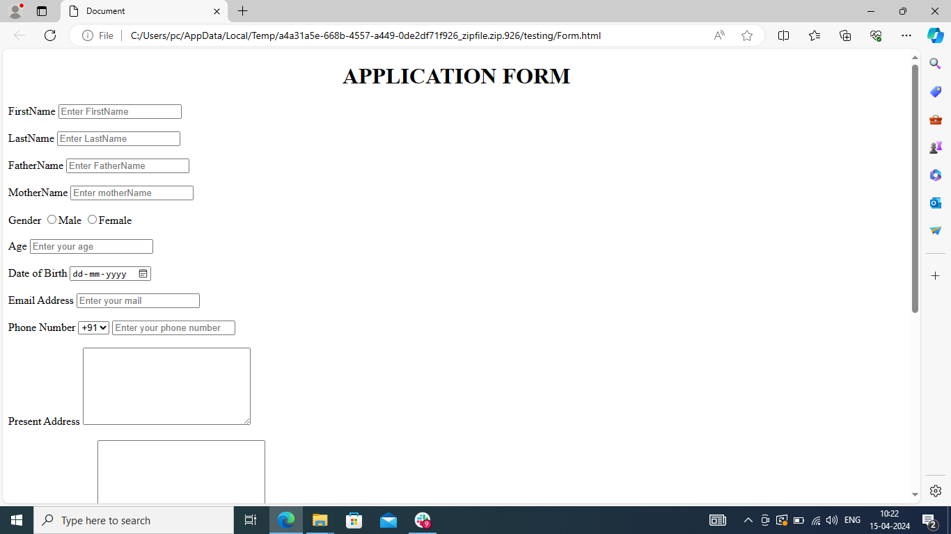

Allignment is not clear for the fields

4 **The alignment of input fields and Space between the input fields is not proper**



Fields are accepting invalid inputs

1. First name field is accepting special Characters and

Numeric values

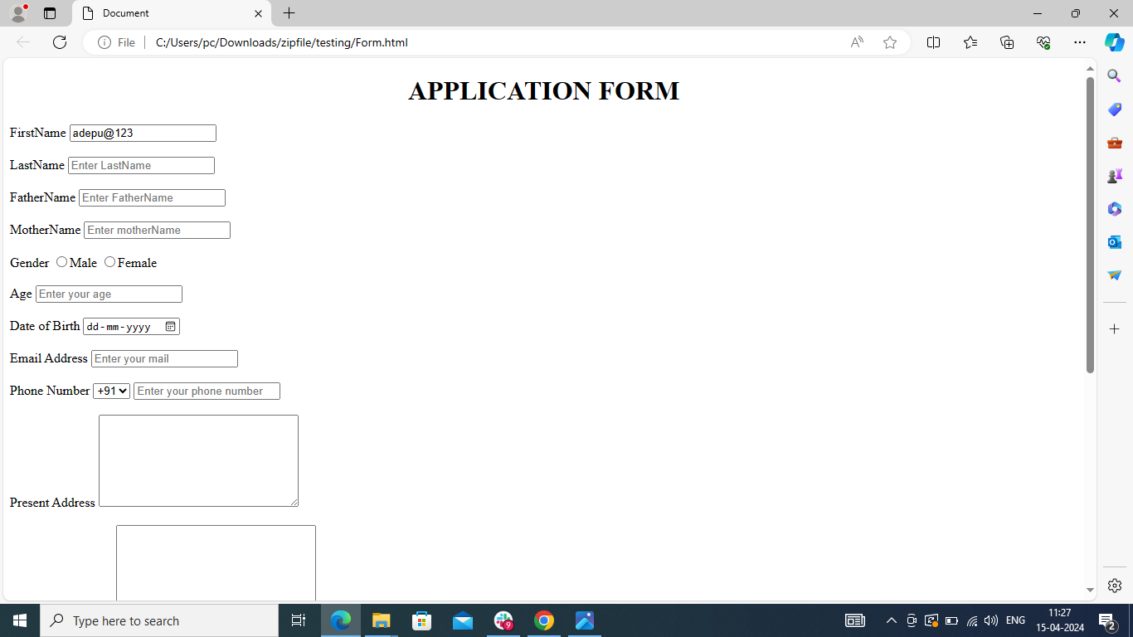

1. Last name field is accepting special characters and numeric values

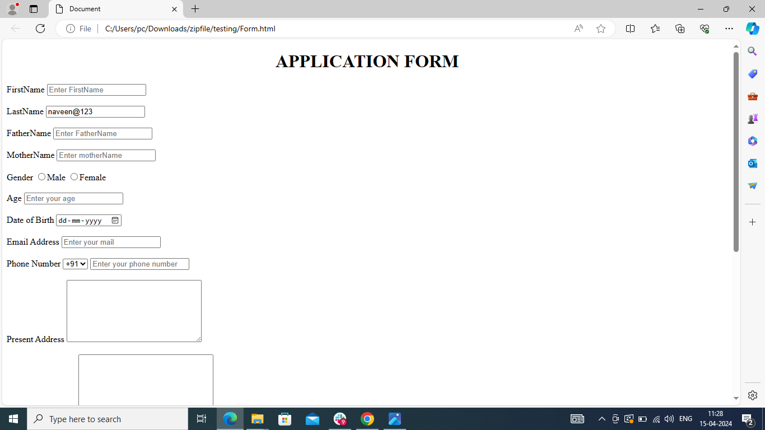

1. Father name field is accepting special characters and numeric values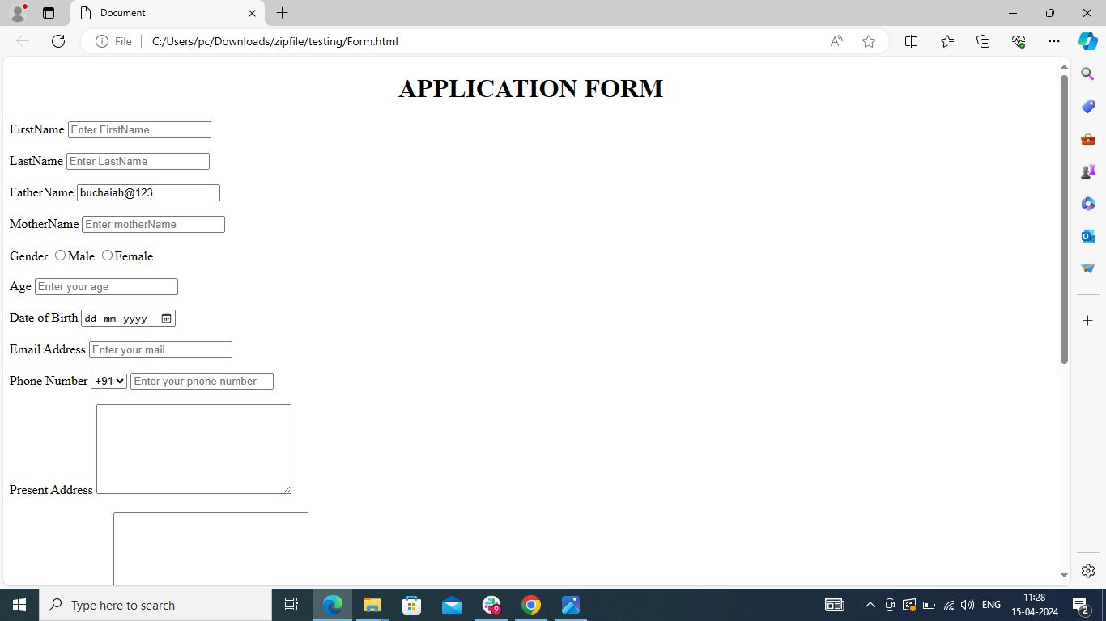
2. Mother name field is accepting special characters and numeric values

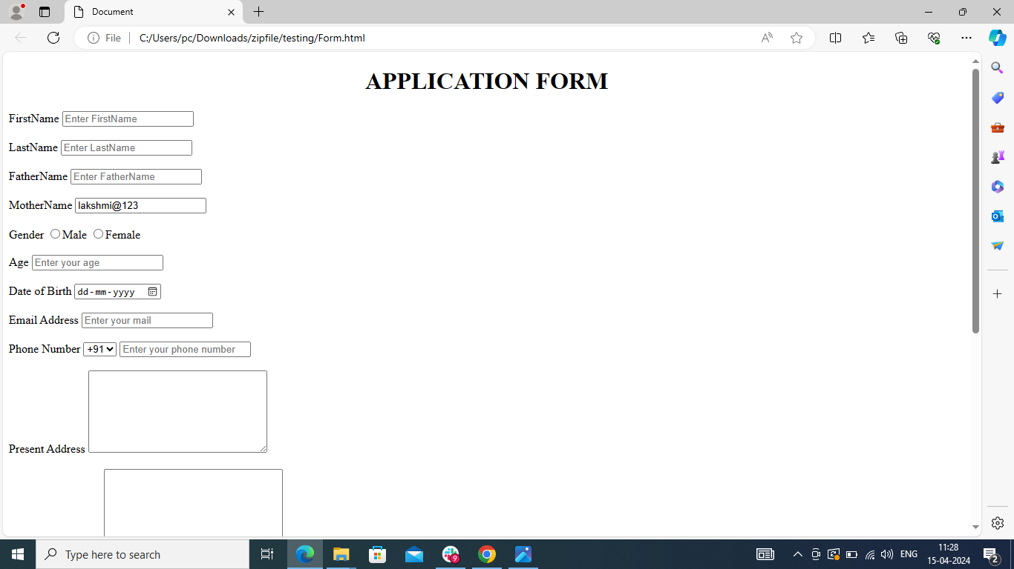

1. First name field is accepting spaces and starting letter with small alphabet

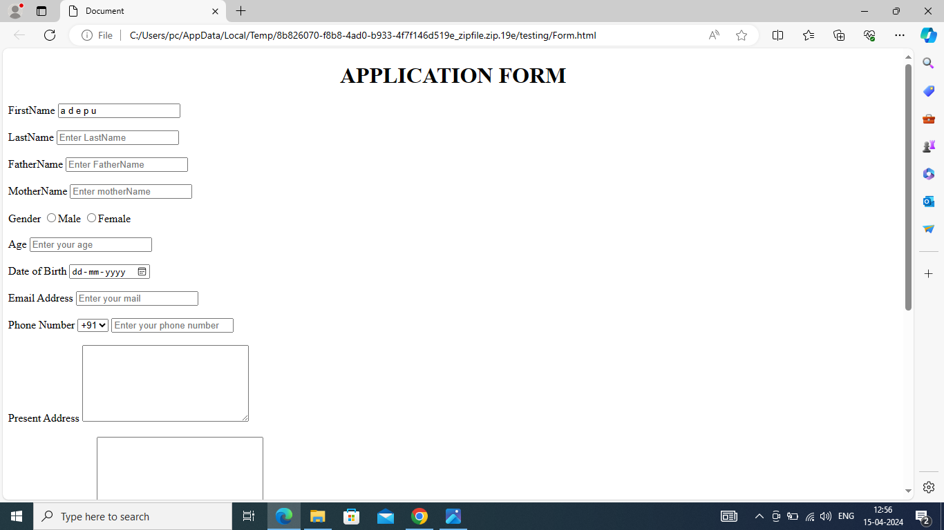

10 Last name field is accepting spaces and starting letter with small alphabet 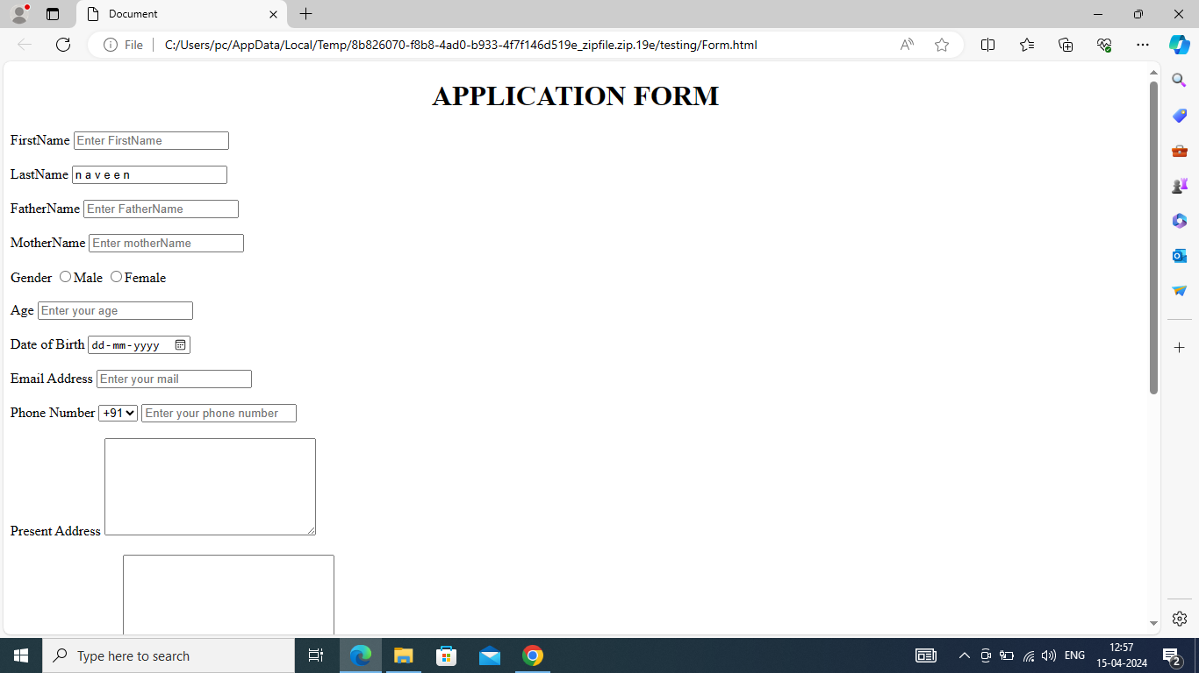

1. Father name field is accepting spaces and starting letter with small alphabet

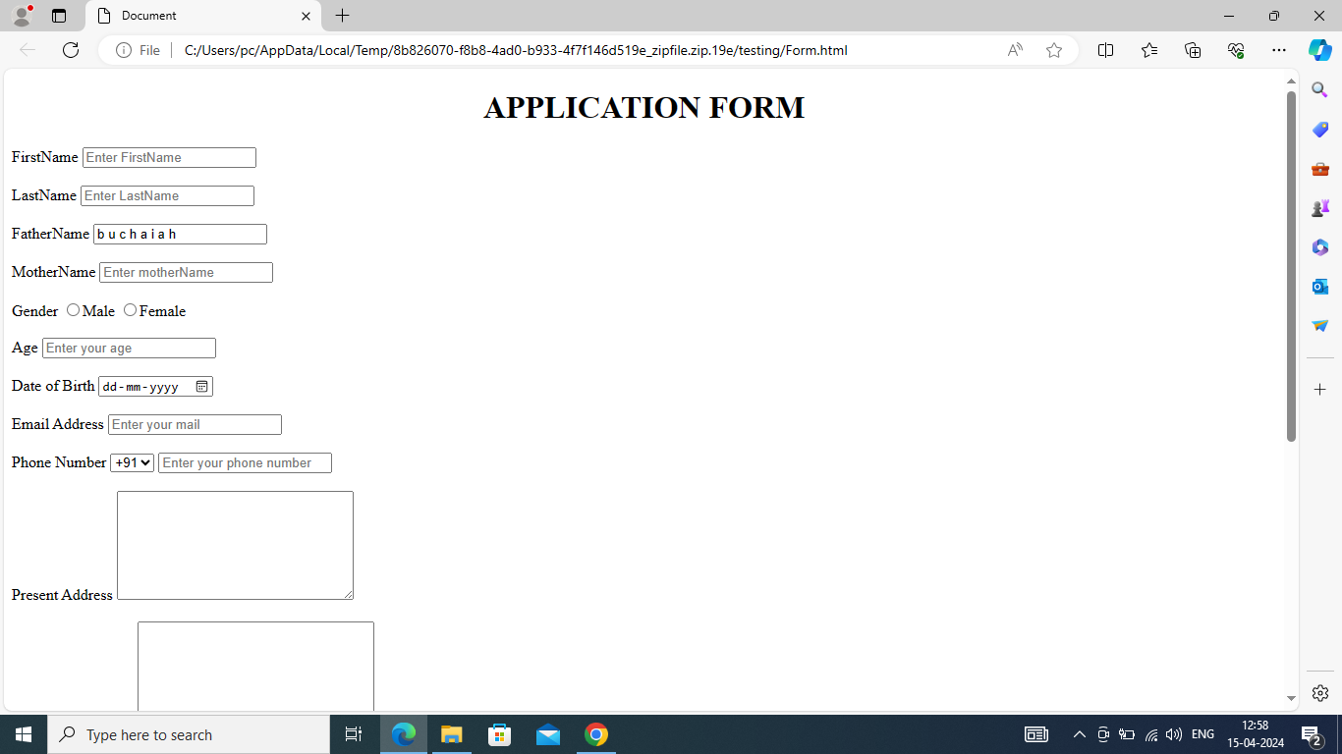

1. Mother name field is accepting spaces and starting letter with small alphabet

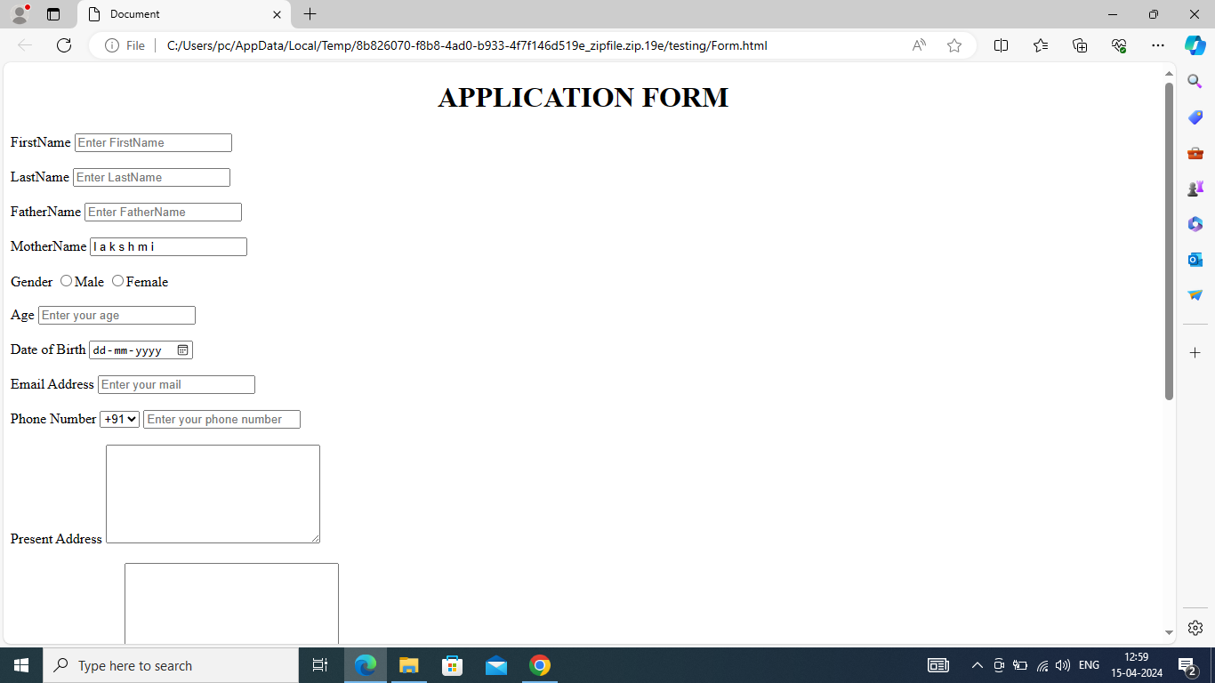

1. Age field is accepting alphabets

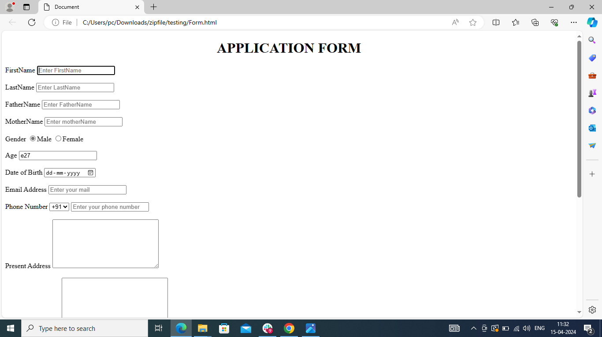

1. Date of birth field is accepting future date

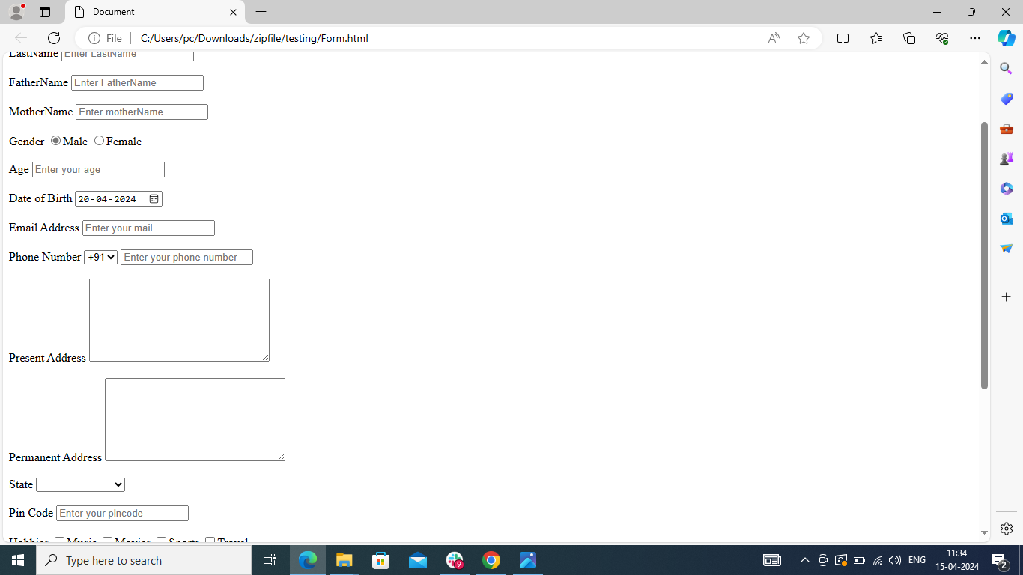

15 Email address field is taking numerical values in starting

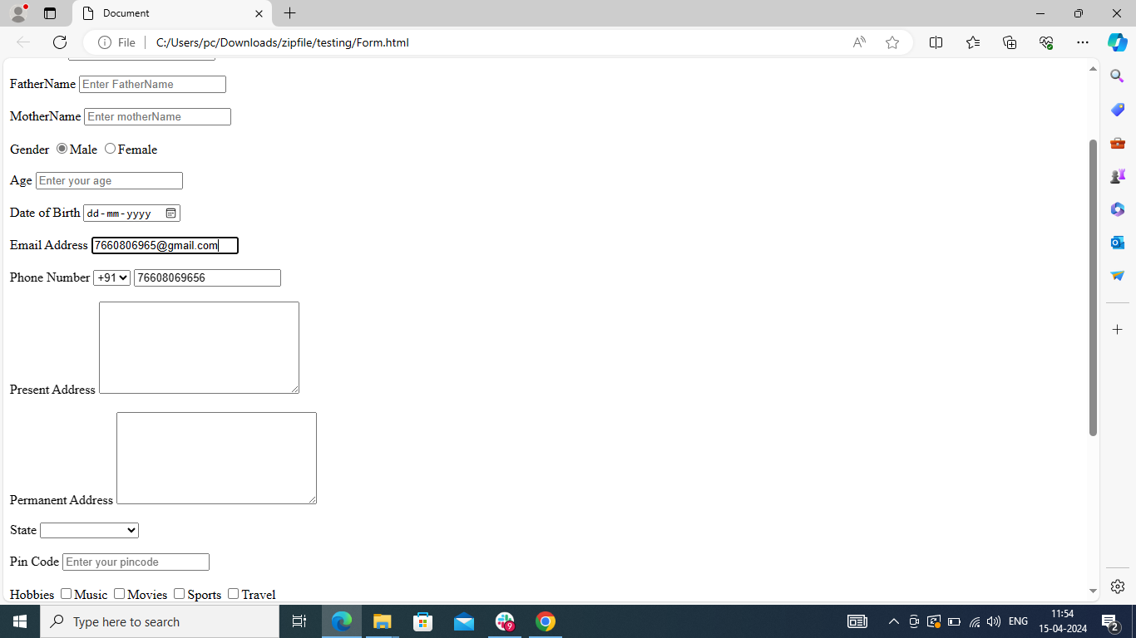

16. Email address field is accepting capital letter in starting

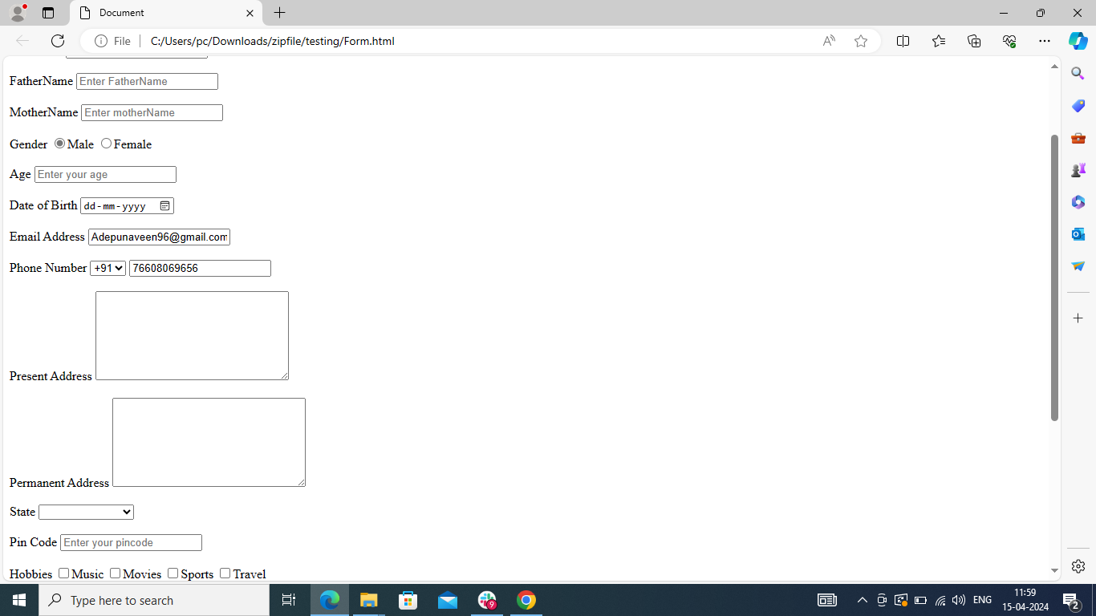

17 Phone number field is accepting all zero’s

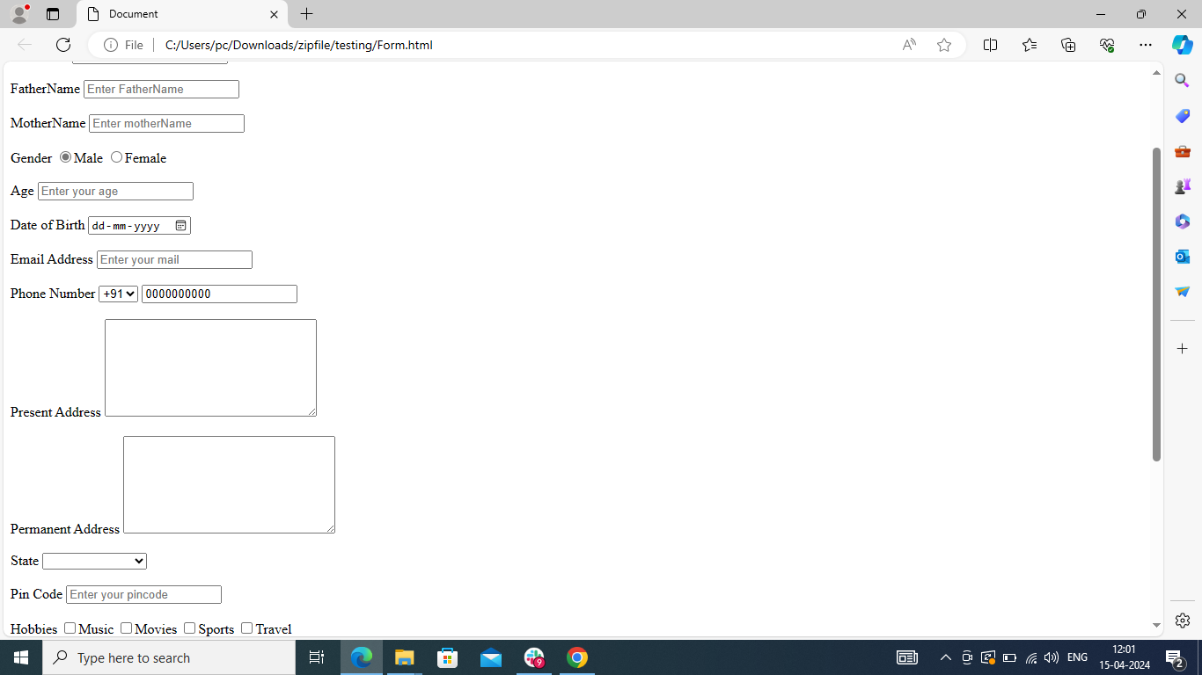

18 Phone number field is accepting starting value zero

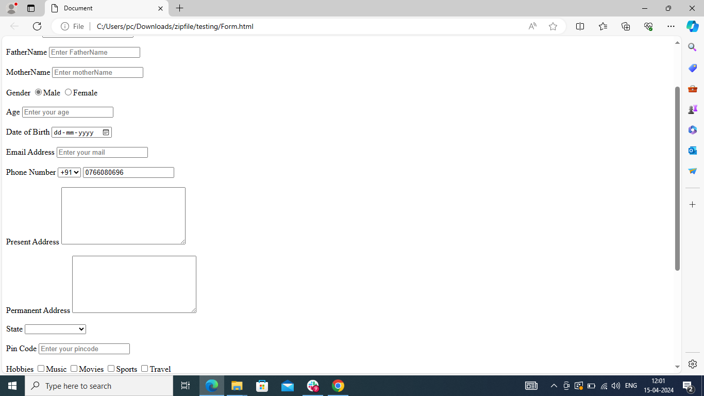

19 Phone number field is accepting less than ten digits 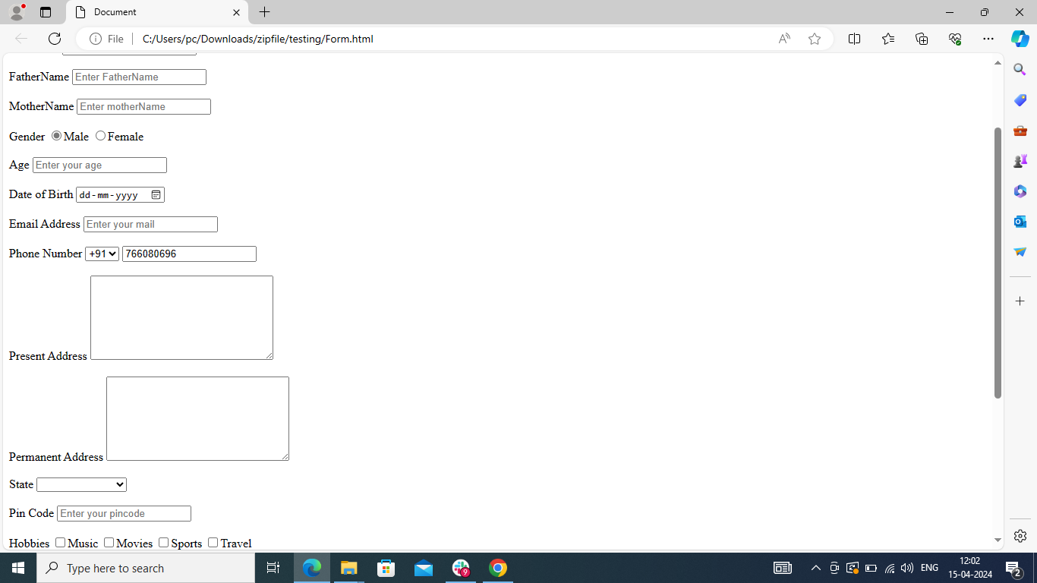

20. Phone number field is accepting more than ten digits

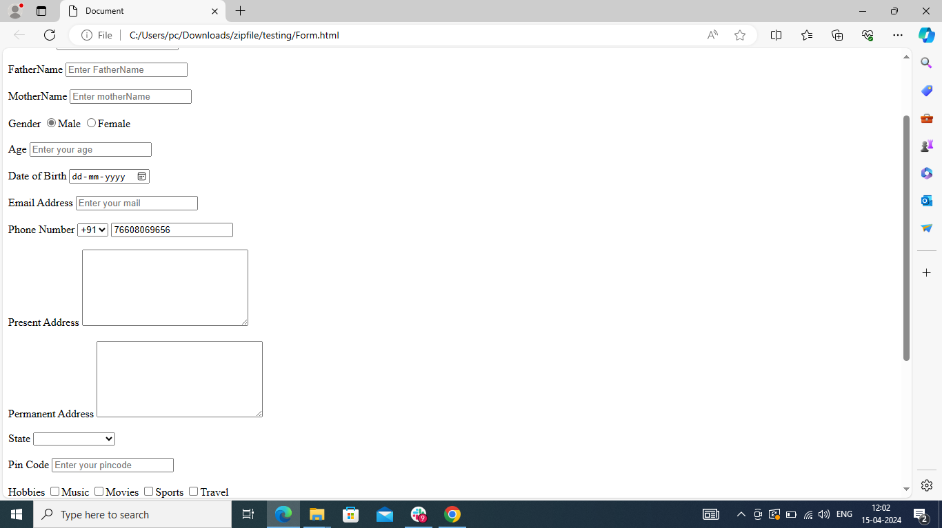

21. Pin code field is accepting less than six characters

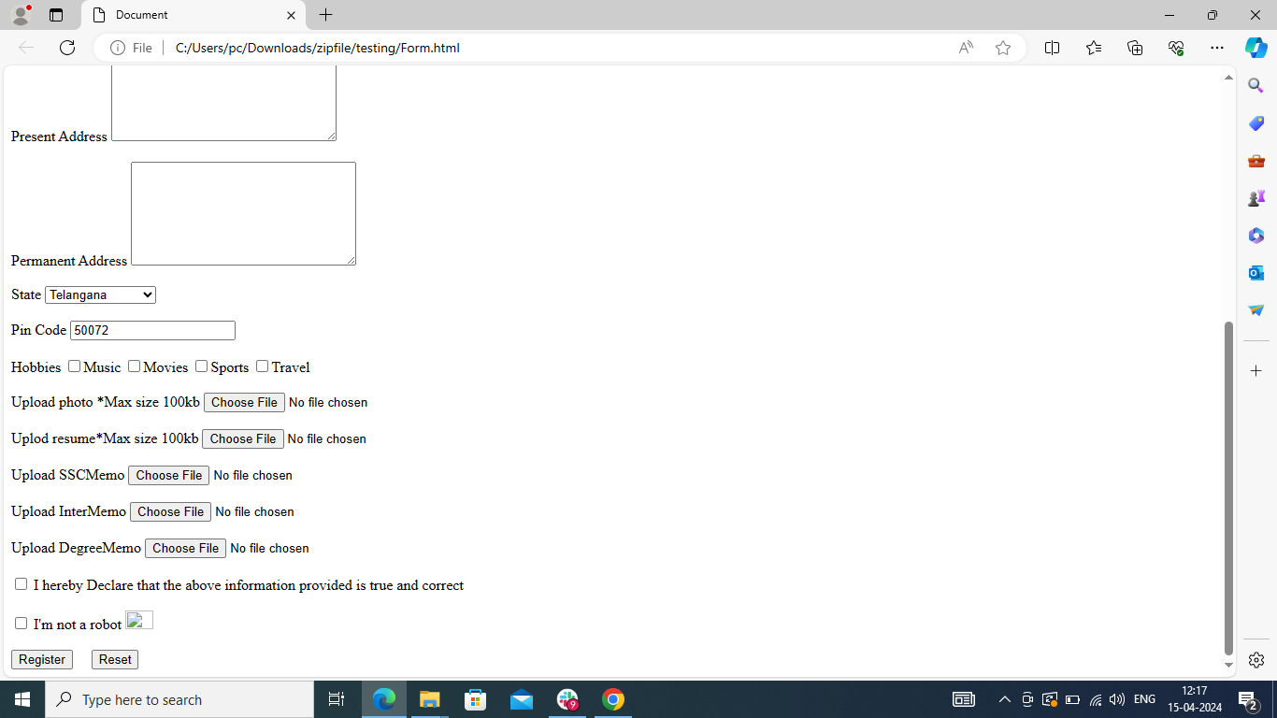

22 Pin code field is accepting more than six characters

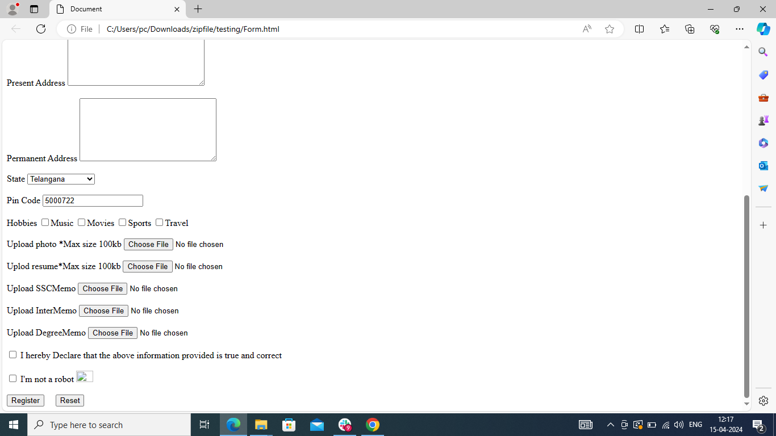

23. Upload photo field is accepting more than 100 kb image

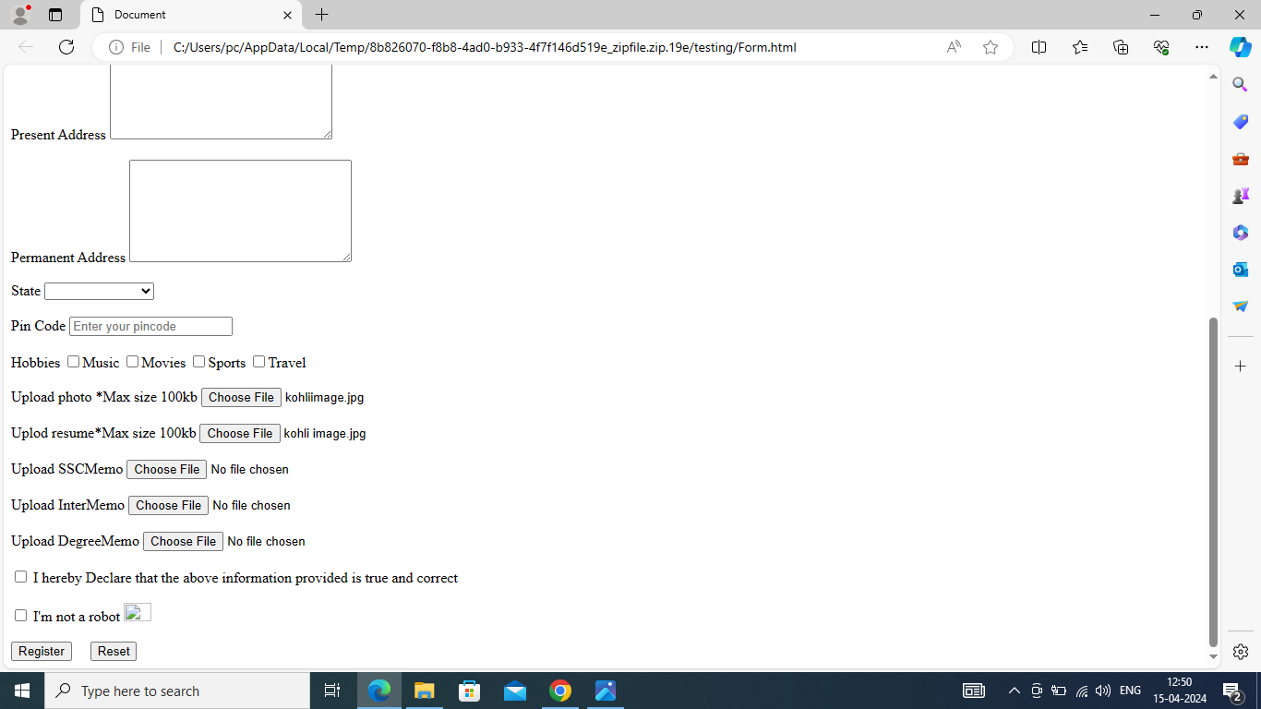

24. Upload resume is accepting more than 100 kb

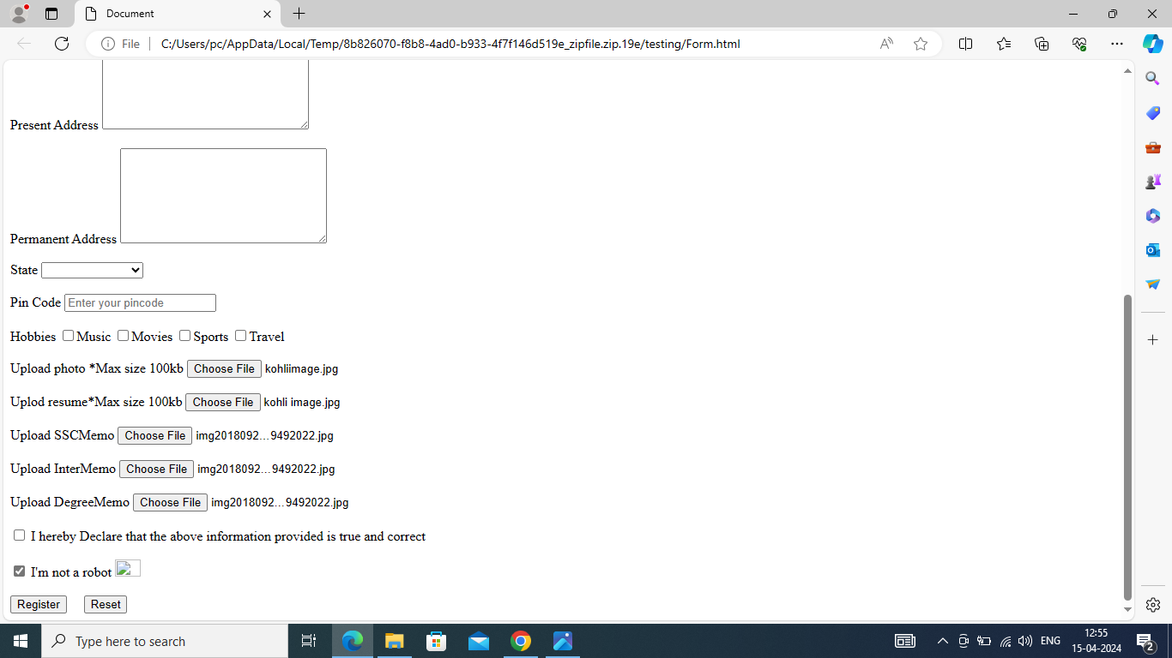

25. Image in I’m not a robo is in smaller size



26. Register field is not working properly

